Name: Shubham Jha

Div: D15C

Roll No:19

**Experiment 2 : Elastic Beanstalk**

1. Go to services and choose elastic Beanstalk. following page will appear.

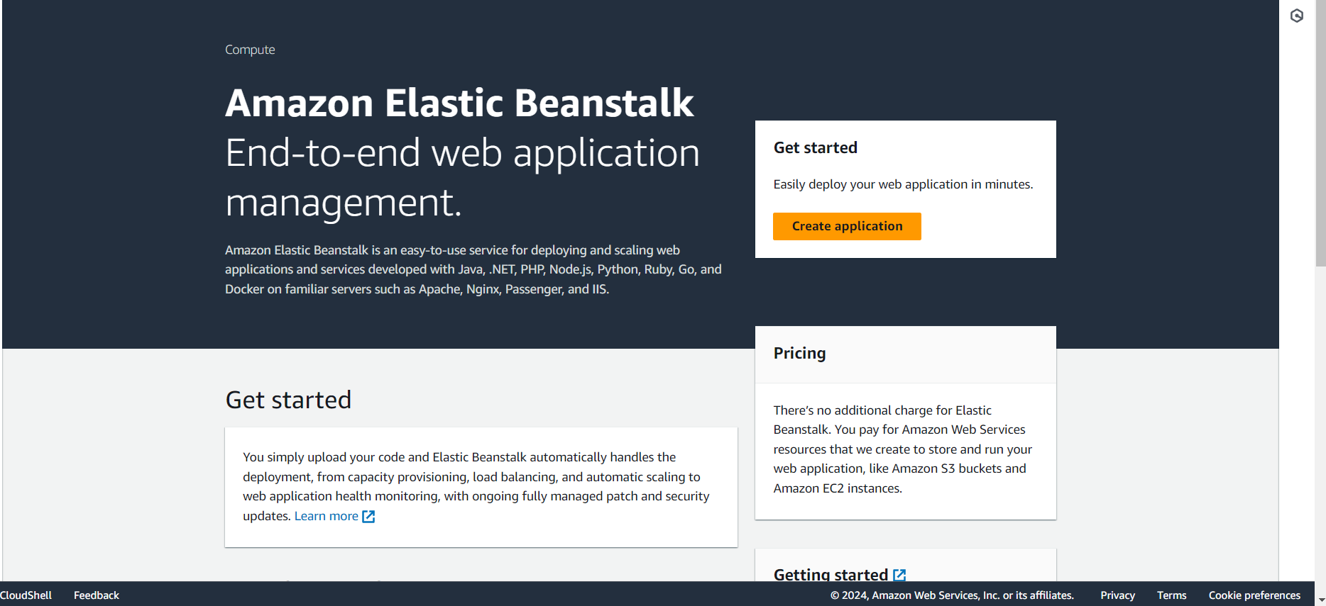

1. Configure the environment. Give the application name, check domain availability and choose PHP as platform.Then click next.

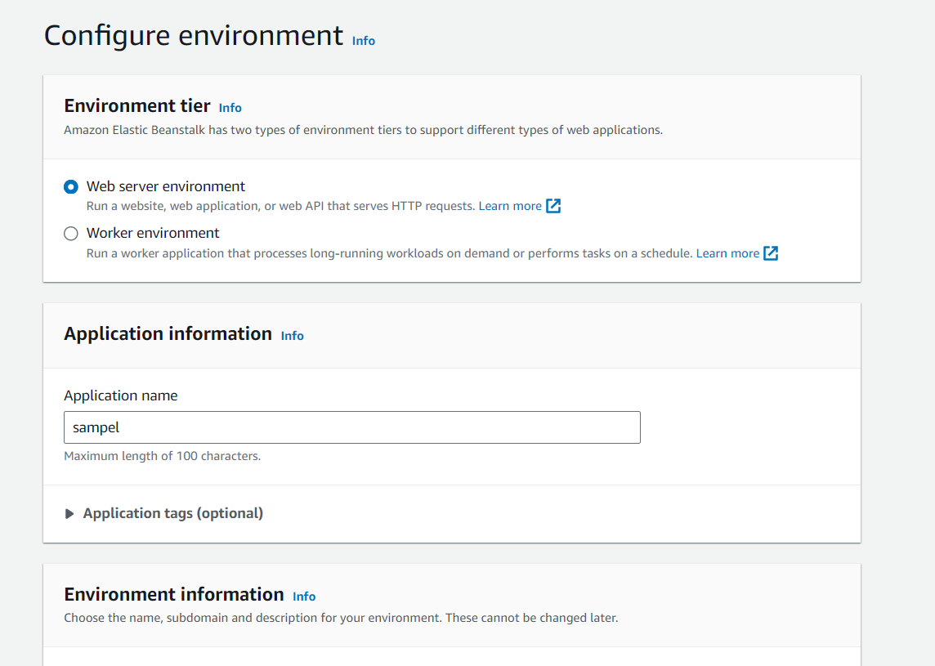

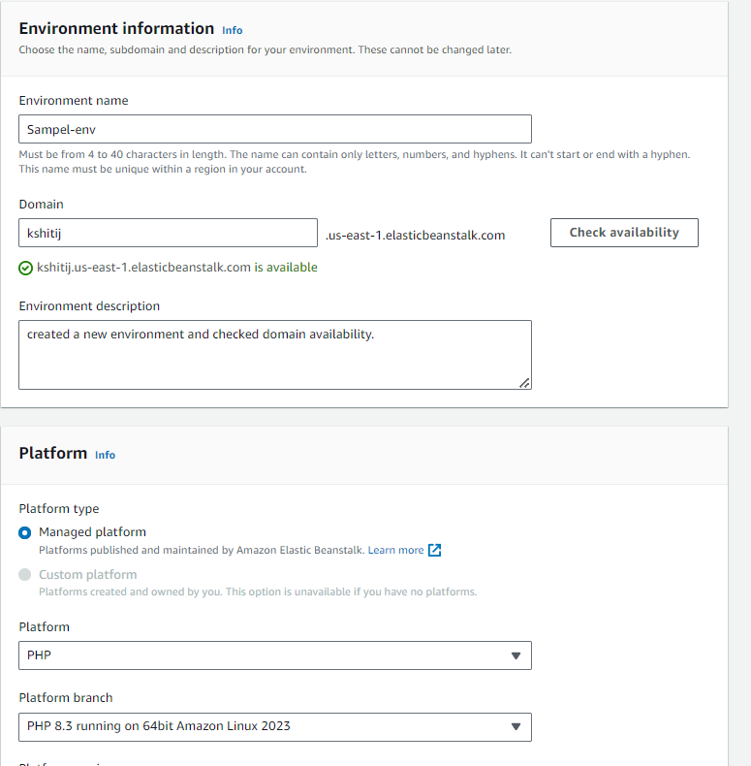

1. Configure the service access.

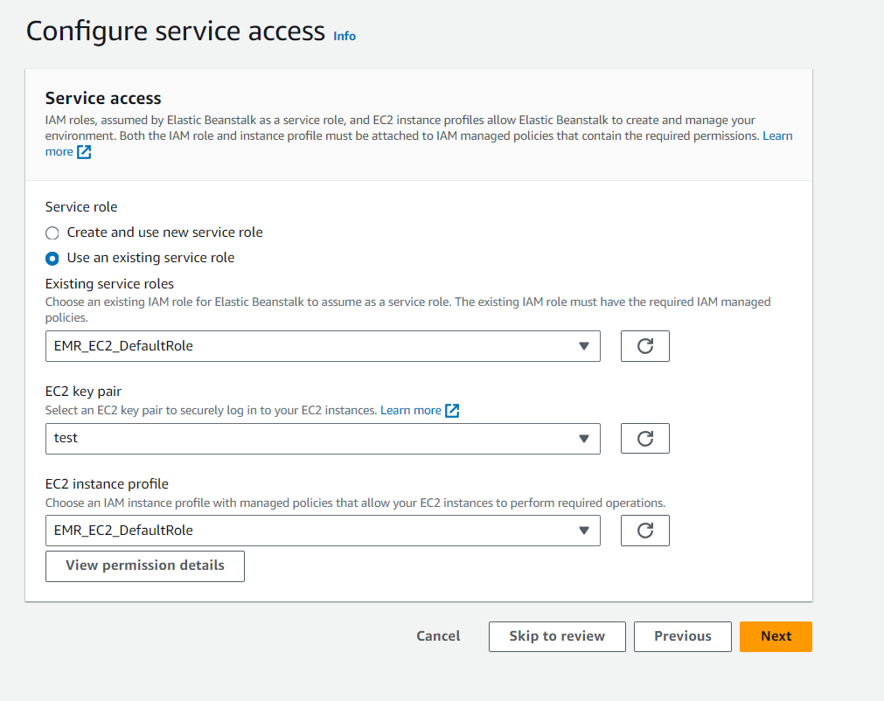

1. Choose one of the available VPC and instance subnet. Click next.

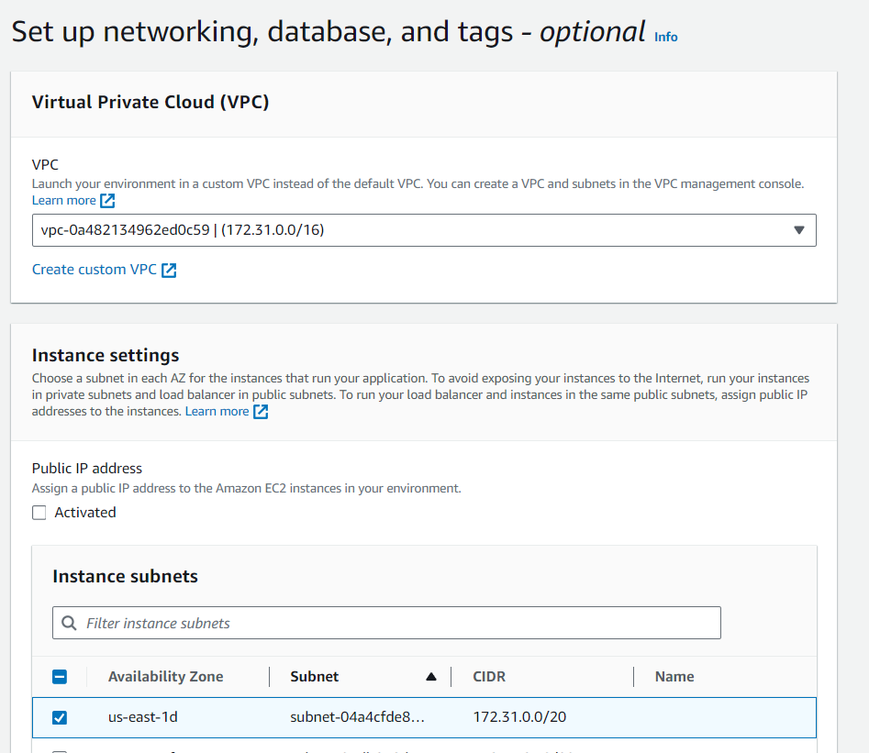

1. Configure instance traffic and scaling. Keep all the options as default.

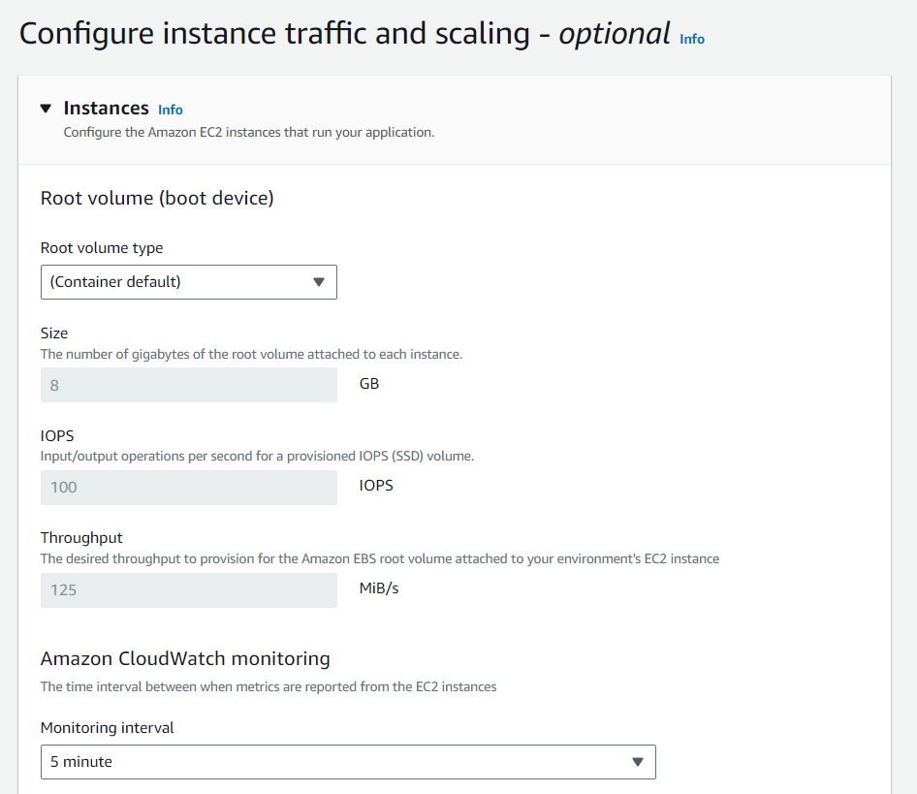

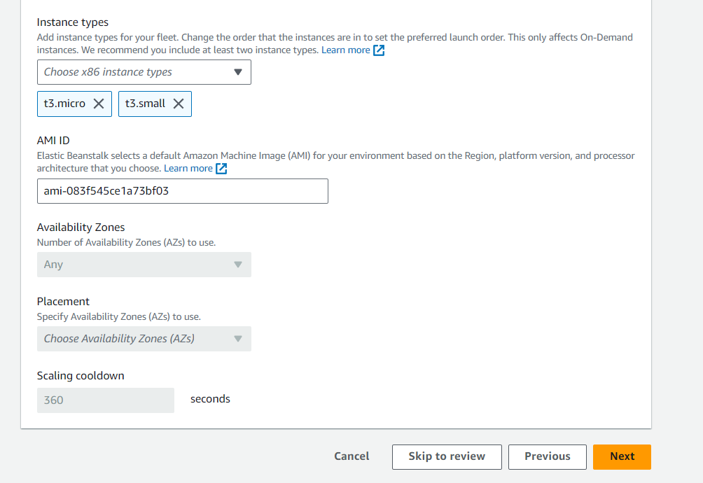

1. Configure updates, monitoring, and logging. Keep everything as default and click next.

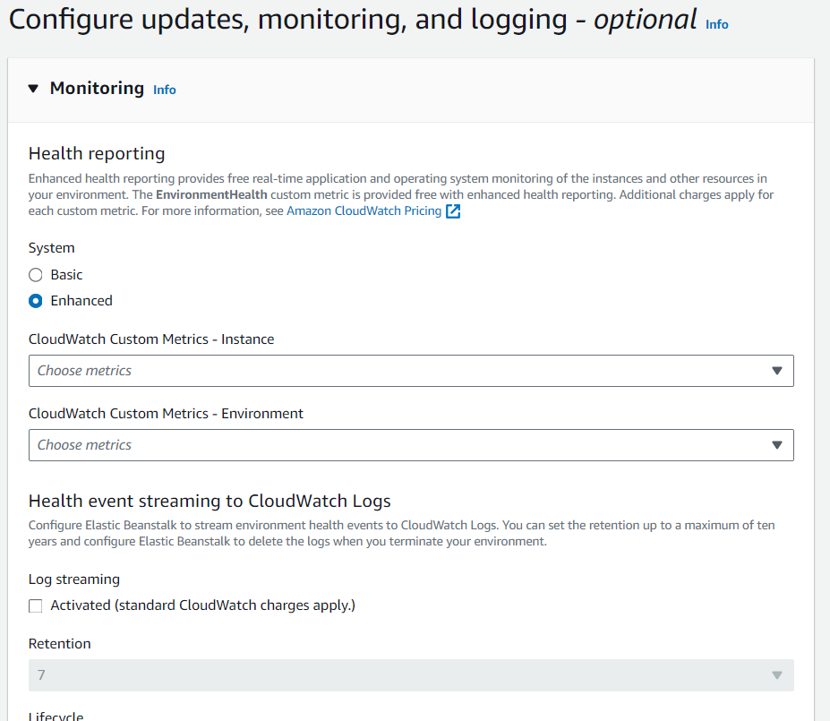

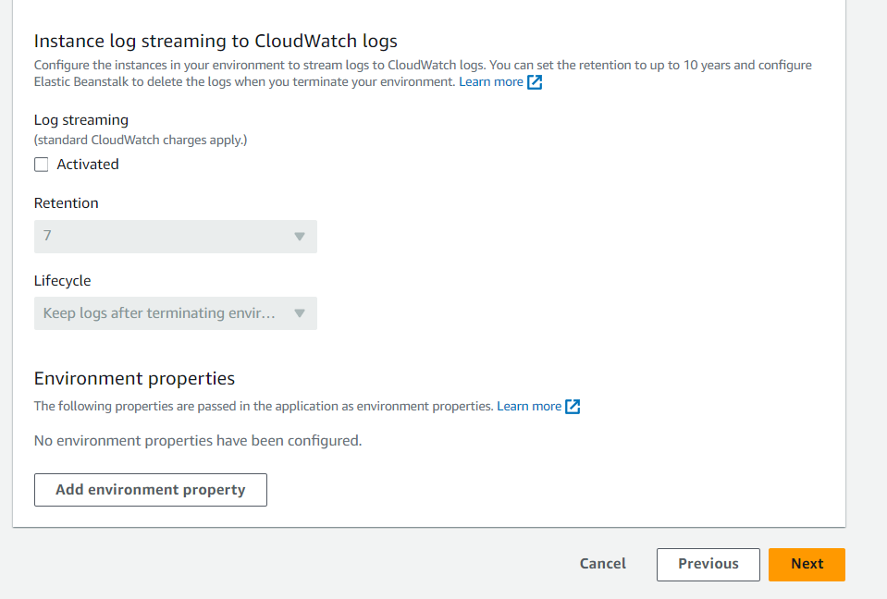

1. Click submit.

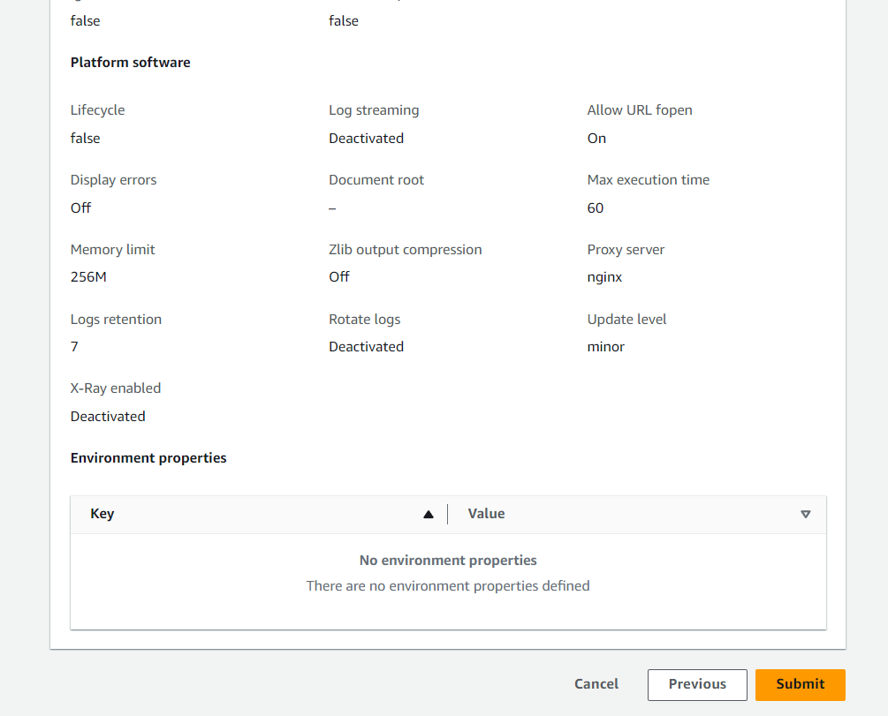

1. Environment has been created successfully.

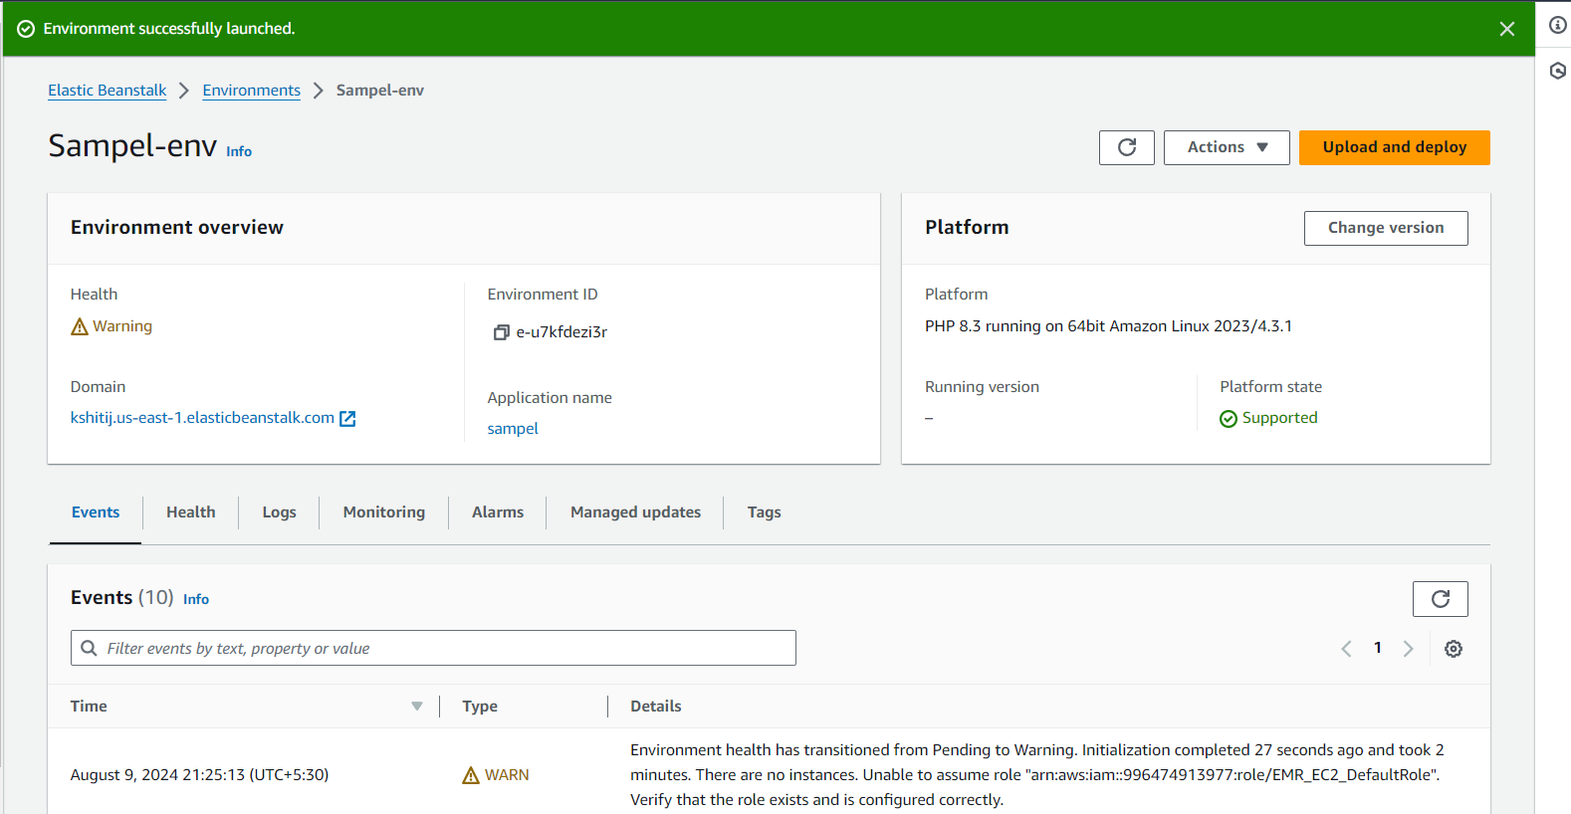

1. Deploy something on the recently created environment.

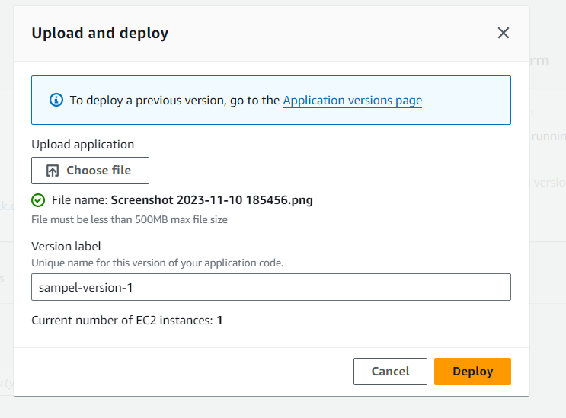

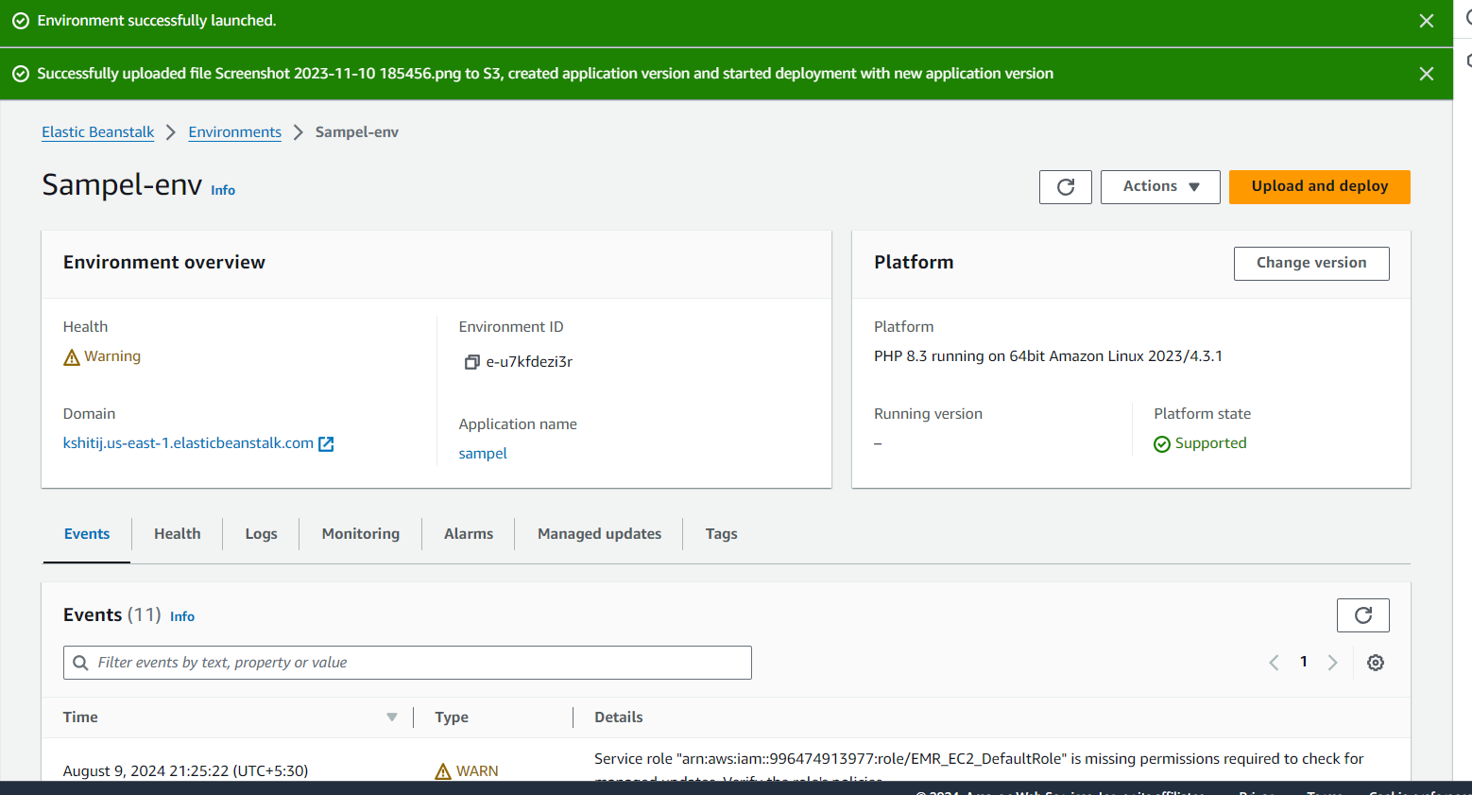

**Pipeline Creation:**

1. Fork a git-hub repository. This forked repository will act as source for your code pipeline.



1. Go to developer tools and select CodePipeline and create a new pipeline

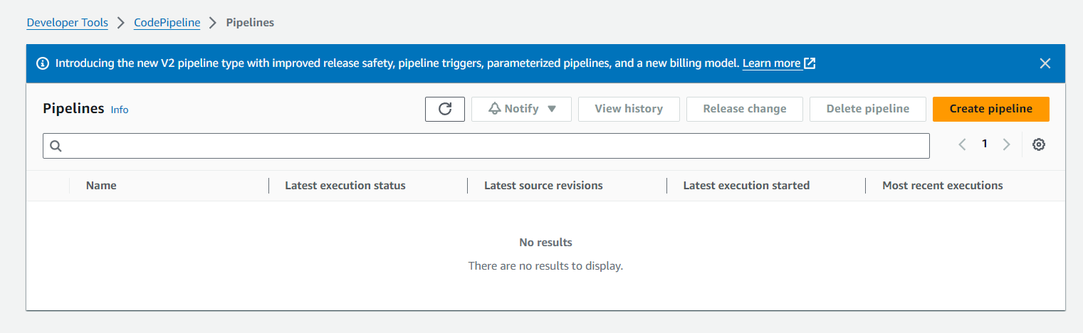

1. Create a pipeline:

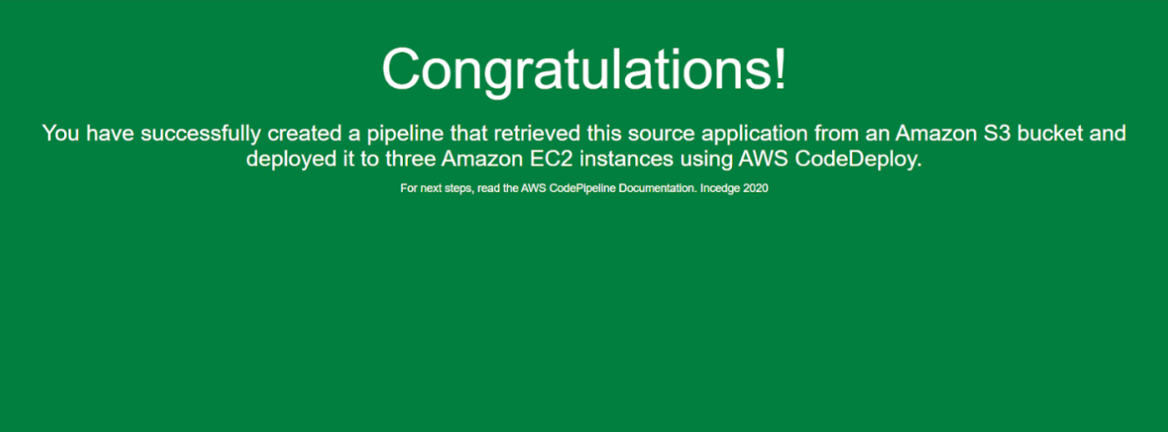

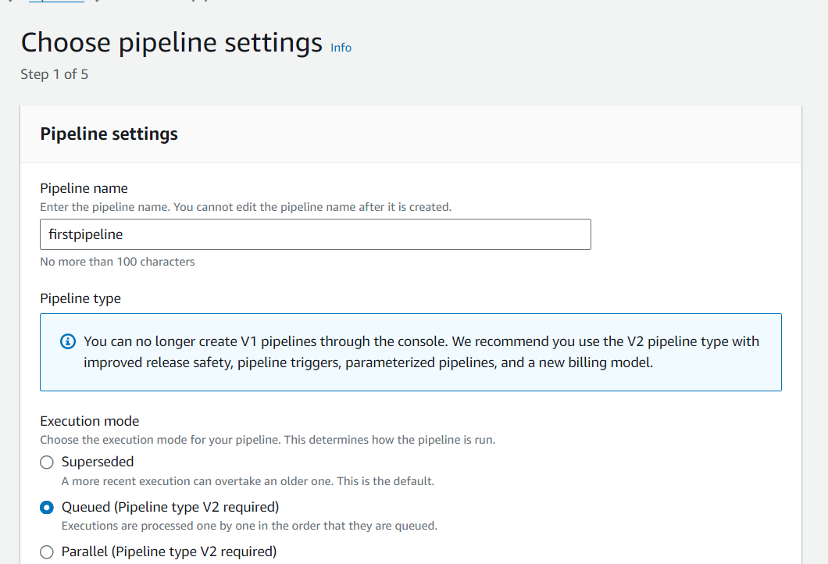

4)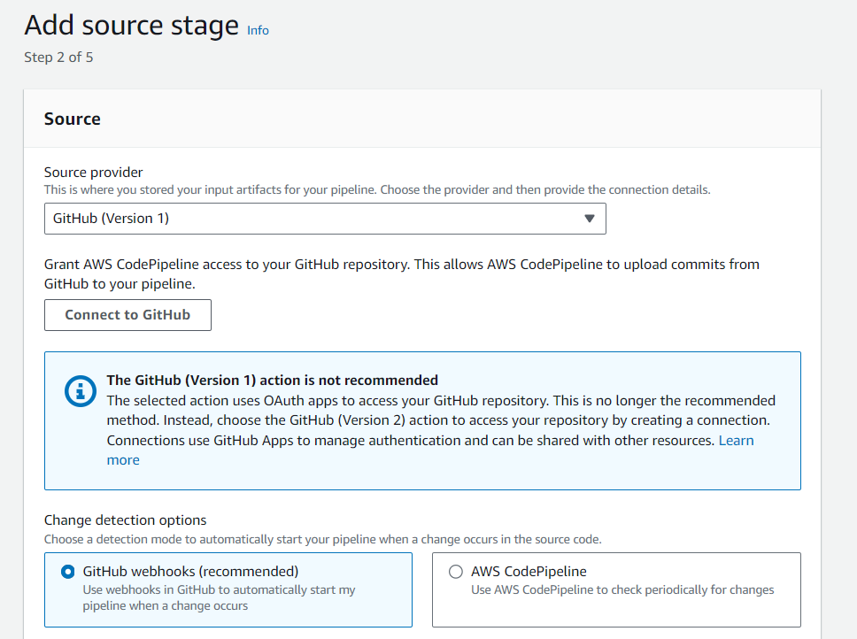

s

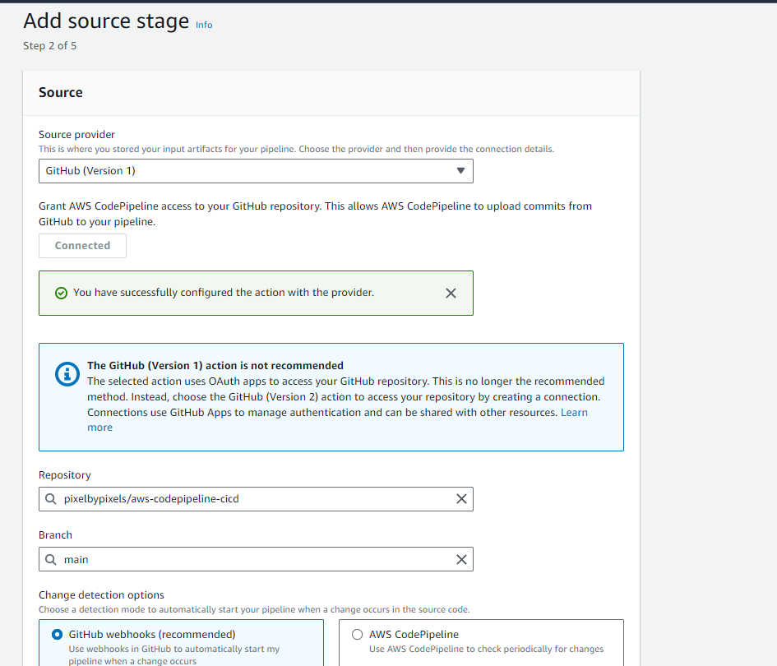

5) Go to the deploy stage and ensure the following settings.

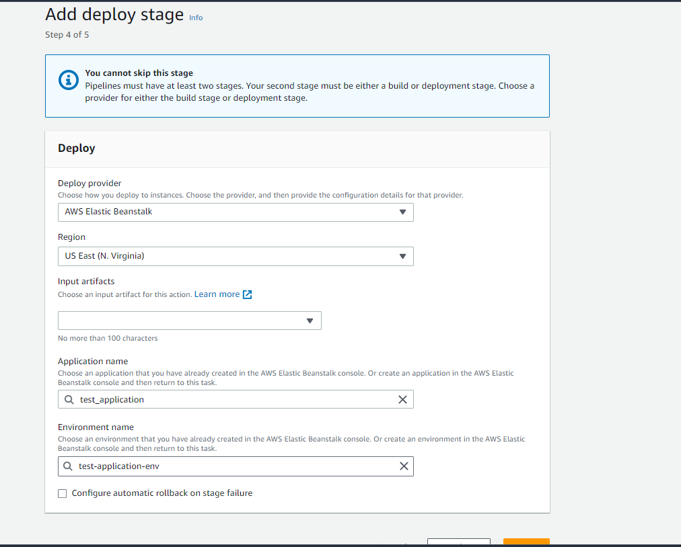

6) review the pipeline settings.

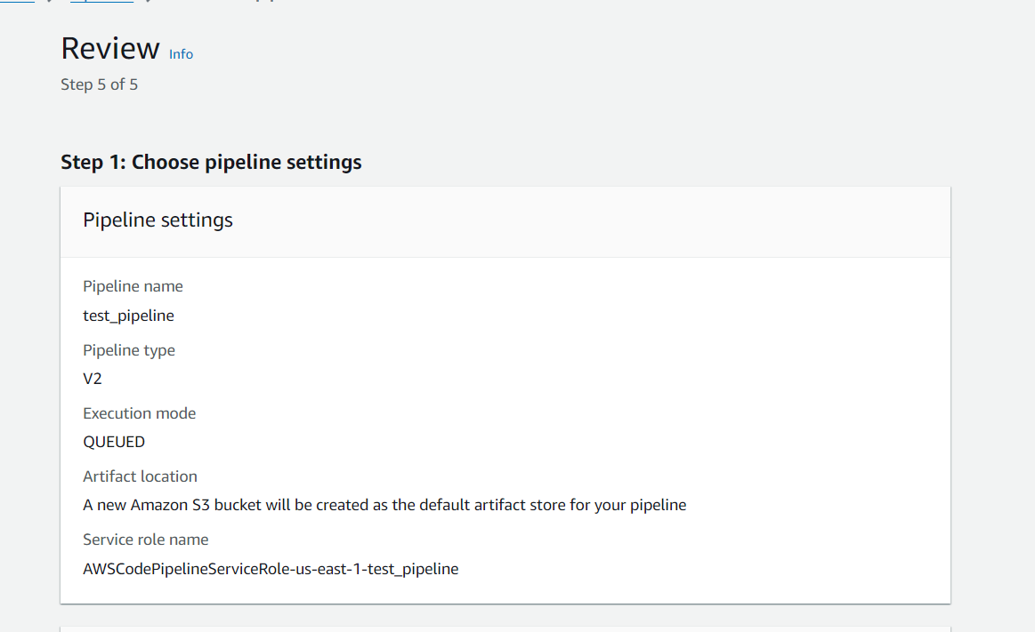

7) Then go ahead and check the URL provided in the EBS environment.

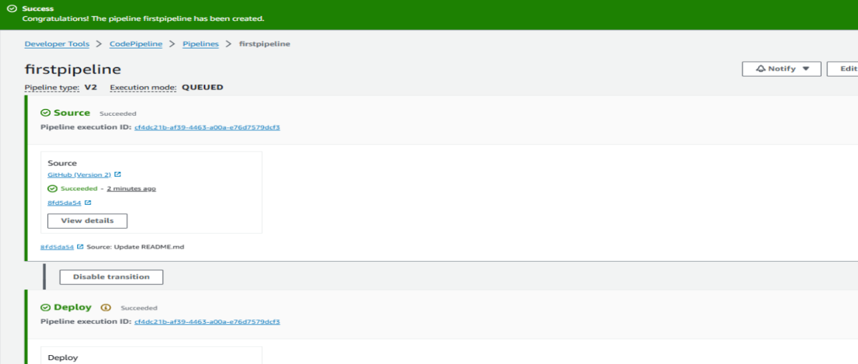

8) Go to the repository and make the changes in the index.html file and commit them

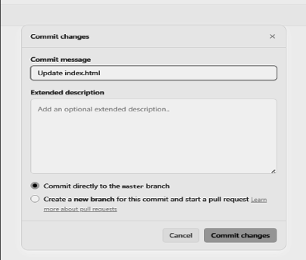

9) To view the changes made, ensure they are committed and visible in the source panel in real time. After confirming that the deployment section indicates success, refresh the URL to see the updates reflected on your site or application.

